Web3D Graphics Publishing with X3DTM
2002 Symposium Tutorial

Nicholas Polys
VirtuWorlds LLC – 3DeZ.net
Web3D Consortium

Introduction & Structure of talk:
- Web3D Graphics
- Publishing Web3D – issues and approaches for any encoding
  - Design & Conceptualization
  - A ‘Document’
  - Example 1
  - A ‘Dynamic Document’
  - Example 2
  - A collection of ‘Documents’
- X3D XML Encoding
- XSLT Transformations
- Serving Documents
- Example 3
- Autogenerating archives/ releases
- Summary of publication paths

Web3D Graphics

Publishing needs:

A structured yet flexible data format to describe and deliver real-time 3D objects and environments

Scalable pathways to integrate and distribute intellectual property to common platforms (WWW, CD, DVD)

Interoperable and reusable content- not bound to proprietary tools and systems

Publishing considerations & requirements:

Data source and production workflow

Target Platforms & Delivery: hardware, software, connectivity

Publishing solutions:

The X3D standard provides multiple profiles to address various domains of 3D media

X3D is Extensible, providing authors the power to add and integrate application components

Allows points of interoperability with W3C and MPEG

Producing X3D

Profiles:

Interchange

Interactive (MPEG4)

Extensibility

VRML97

Components

Publishing Web3D – issues and approaches for any encoding

Design & Conceptualization
Typical process:
- Abstraction & Ontology (what exists) - Data Model
- Story boarding/scene blocking
- Architecture
- Production & Implementation
- Integration
- Delivery

Scene Design – by ‘blocks’

Design is 60% of production!

The degree of ‘granularity’ & ‘encapsulation’ in your scene abstraction will impact the data representation, its production, as well as its storage and retrieval.

Define environment & locations

Define User Interface & Viewpoints

Model objects

Define interactions

Organize and collect scene
- Optimize scene with post-production tools

Application Design

Data Abstractions first, Procedural Abstractions last.

- Abstracting your scene ontology by ‘blocks’ is a data-centric approach- it strives to encapsulate (hide) the actual data structures, preferring instead to expose a limited, and <hopefully> well-documented interface to behaviors. Then one can formalize a set of functions (procedures) that know how to manipulate these data structures.

- Focusing on data has 2 big advantages: Data structures tend to be something you can identify with and they are relatively stable across applications

- Finally, a system divided into data-centric modules can be easily apportioned among a team of programmers. All changes to a given piece of data or a set of related data are done only by its "owner"; that developer becomes a component supplier for other people in the project.

Authoring Tips

Use IndexedFaceSet; avoid Sphere

Avoid deeply nested transforms

As often as possible, do not scale or transform objects into position

Divide large worlds according to desired user experience

(with LODs, VisibilitySensors and Switches)
- Self-sufficient scene blocks may instantiated as Inlines

A ‘Document’

Content type
Header
PROTOs & EXTERNPROTOS
World set (proximitySensor)
HUD & User Interface
Scripts
Environment set
ROUTES

Example
Publish in HTML page (different browsers and even different version of the same browser (IE vs NS) may treat these tags differently). Generally:

<OBJECT DATA=” http://www.web3d.org/images/x3danywhere/3Dlogo/X3D_everywhere3b.wrl"” WIDTH="185" HEIGHT="138" >
<PARAM NAME=” VRML_DASHBOARD” VALUE=”FALSE”>
<EMBED SRC="http://www.web3d.org/images/x3danywhere/3Dlogo/X3D_everywhere3b.wrl" "
WIDTH="185" HEIGHT="138" VRML_DASHBOARD="FALSE" HSPACE=”10” VSPACE=”15”ALIGN=”MIDDLE” ></EMBED>
</OBJECT>

generically for legacy:
<object data="http://www.web3d.org/images/x3danywhere/3Dlogo/X3D_everywhere3b.wrl" type="model/vrml" width="325" height="150">
<param name="SRC" value="Logo/LOGO.WRL">
<param name="VRML-DASHBOARD" value="FALSE">
<param name="SGI_DASHBOARD" value="FALSE">
<param name="VRML_POPMENU" value="TRUE">
<param name="SGI_POPMENU" value="TRUE">
<param name="VRML_IMAGEQUALITY" value="BEST">
<param name="SGI_IMAGEQUALITY" value="BEST">
<param name="VRML_SPLASHSCREEN" value="FALSE">
<param name="SGI_SPLASHSCREEN" value="FALSE">
<param name="VRML_FULLCOLOR" value="TRUE">
<param name="VRML_DITHERING" value="TRUE">
<param name=”World” value=”http://www.web3d.org/images/x3danywhere/3Dlogo/X3D_everywhere3b.wrl”>
<param name=”Scene” value=”http://www.web3d.org/images/x3danywhere/3Dlogo/X3D_everywhere3b.wrl”>
</object>

Forcing a browser by <OBJECT CLASSID=”clsid:xxxx”>

ParallelGraphics Cortona
<OBJECT CLASSID="clsid:86A88967-7A20-11D2-8EDA-00600818EDB1">
blaxxun Contact
<OBJECT CLASSID="clsid:4B6E3013-6E45-11D0-9309-0020AFE05CC8">
Cosmo Player
<OBJECT CLASSID=" clsid:06646724-bcf3-11d0-9518-00c04fc2dd79">
Microsoft VRML 2.0 Viewer
<OBJECT CLASSID="clsid:90A7533D-88FE-11D0-9DBE-0000C0411FC3">
InterVista WorldView
<OBJECT CLASSID="clsid:b4d99696-acb2-11d1-a635-00609753e802">
Viscape Universal
<OBJECT CLASSID="clsid:1b487523-BEC2-11CF-BF9E-0020AF998FF5">
</OBJECT>

Manage pop-ups and windows
where, in parent HTML:

<HEAD>
<script language="JavaScript">
<!--
onerror=null;

function openWin (popup)
{
if (!top.infoFrame1 ){
infoFrame1=window.open(popup,"infoFrame1",config="toolbar=no,width=700,height=275,status=yes,scrollbars=yes,resize=yes,menubar=no");
infoFrame1.focus();
}
else {top.infoFrame1.location.href = popup;
top.infoFrame1.focus();
}
}
// -->
</script>
</HEAD>

The scene or PROTO type may then contain:

DEF PopupLoader Script {
eventIn SFTime set_info
eventIn MFString loadUrl
field MFString s ""
field MFString hurl ["http://www.Web3D.org/x3d/x3d_news.html"]
url "javascript:
function loadUrl()
{ s= new MFString('javascript:openWin(\"'+hurl[0]+'\")');
Browser.setDescription(s);
Browser.loadURL(s,TARGET='_top');
}
"
}

Sniffers are also an effective technique to deliver Web3D in a robust way;
the Con is multi-tiered systems (concurrent data) are more difficult to scale and maintain.

- Test browser plugins and supported mime types
- If a VRML browser is present, document.write an <object> or <embed> tag
- If not, document.write an imagemap, link, or other html

With the VRML browser detector by Robert Lippman of NIST (see references), you can use the conditional tests to embed different files depending on the plug-in present.
It is written in JavaScript 1.2 and VBScript, unencumbered (free), and is easily customizable.

A ‘Dynamic Document’

Built on-the-fly (server-side) according to user preferences stored in a database: For example, their ‘Home’ world, User Interface and Head-Up-Display ‘skins’, inventory, etc.
- 3D data (scene blocks) can also be loaded from files or from a database. This is a design issue that depends on the production process for 3D data and the underlying application implementation (database session management for example)

Dynamic techniques

PHP & MySQL – shared reflections on a 3DeZ demo build
[could also be done with Perl or Java DB connections and any database]

- check for cookie
- if no cookie and not filled out form, open register page
- if no cookie and form filled out, check input, INSERT into database, and set cookie
- if cookie is present, load user info from database into variables
- set content-type and header
- use user-info to build and instantiate scene blocks in the document
- serve built document (may be gzip compressed)

With a system built with PHP, it is fairly straightforward to add multi-user ‘gateways’ to a scene (ie wrap the scene for use in the Deep-Matrix or blaxxun multi-user system).

On your webserver, you might want to build an X3D document with php or some other server-side scripting language, but still have your VRML plug-ins recognize it when it is received or embedded in a page. You can specify MIME Types for a given folder by adding for example:
AddType application/x-httpd-php .php .wrl
Or other definition to your .htaccess file

A collection of ‘Documents’

Building your scenes by blocks (as described above) will allow you to use to one of the most powerful and under-rated techniques in Web3D- those methods made available by the Browser class:

Browser.createVrmlFromURL(String[] url, BaseNode node, String event);

DEF Loader Script {
eventIn MFString loadUrl
eventIn MFNode vrmlLoaded
eventOut MFNode node_changed
field SFNode myself USE Loader
field SFNode texter USE HUDTextScreen
field MFString lastUrl ""
url "vrmlscript:
function loadUrl( str, ts )
{
last = str;
var loc1 = new MFString('Location 1');
var loc2 = new MFString('Location 2');
if (last[0].indexOf('1') !=-1) {
texter.set_string= loc1;
}
else { if (last[0].indexOf('2') !=-1){
texter.set_string= loc2;}
}
Browser.createVrmlFromURL( str, myself, 'vrmlLoaded' );
}
function vrmlLoaded( nd, ts ) {
node_changed = nd;
}
"
mustEvaluate TRUE
}
ROUTE button2.url_changed TO Loader.loadUrl
ROUTE Loader.node_changed TO World_2.set_children

Where World_2 is a Group node whose children are replaced when the function is evaluated
(the ‘Environment set’ block as referred to above).
Using this technique, user persistence (presence) may be maintained across the documents.

X3D- XML Encoding

Strictly speaking, X3D (and VRML97) is a file format for describing 3D scene graphs. It is not a runtime in and of itself. The specification describes runtime behavior in an abstract way; different implementations (browsers) may be better at certain operations on certain platforms than others.
Consequently, the complaint that ‘VRML is slow’ in and of itself is a red herring.

The great advantage of an XML encoding is that it provides a structured data representation built for the purpose of separating content from presentation. In the case of X3D, this allows us the advantage of manipulating and transforming content independently of its web presentation. This dramatically reduces development and maintenance costs by allowing easy integration of legacy data to a single data representation which can be presented in multiple contexts or forms depending on the needs of the viewer (aka client). Data thus becomes ‘portable’ and different formats may be delivered and presented (styled) according to the application’s needs.

Another important aspect of the X3D XML encoding is that with the tools that XML provides (DTD and Schema), high-level markup tags may be defined. This allows customized and compliant 3D content to be built for use by authors and domain specialists.

Typically, this frames content publishing in a 3 step process:
- XML content creation
- XML processing & logical transformation
- XSL rendering to a target style and content-type

DTDs (Document Type Definition) – defines ‘valid’ or ‘legal’ document structure according to the syntax and hierarchy of its elements

Schema- specifies data types for element’s content (ie attributes) – document’s semantics

In the transcoding of VRML to X3D, this plays out where VRML nodes are ‘elements’ (tags) and fields are attributes. EventIns are unreadable attributes, EventOuts are unwritable attributes; all fields are exposed.
N.B. – XML parsers are case sensitive with regards to tag names.

Other Bonuses: 3D becomes a 1st class media type for the WWW- can play with SVG, DOM, SMIL, etc!

XSLT Transformations

- XSL engines converts XML documents into a tree structure of various nodes
- XSL transforms the XML document using pattern matching and template rules in the stylesheet
- Template elements replace matched nodes in the source document

X3D Task Group has demonstrated:
X3D -> VRML97
X3D -> HTML
X3D -> wrap/unwrap
And, courtesy of NIST: VRML97 -> X3D

Given an X3D document in the XML encoding, developers can apply XSL stylesheets not only to port the data to different presentational formats (html, pdf, POV, etc), but also effect the content according to the target template rules. For a simple example, a user has specified that their color motif preference is ‘southwestern’. Using XSL, the system may modify colors of objects according to this preference.

Other future applications may include transforming CML to X3D, using MathML to drive animations, and more!

Serving ‘Documents’
Example
Perl Build using gnome XML and XSLT libraries:

#!/usr/bin/perl
use strict;
use XML::LibXSLT;
use XML::LibXML;
use CGI;

my $q=CGI->new();

if ( (!$q->param('world')) || (!$q->param('xsltype')) ){
print $q->header,$q->start_html;

print <<END;
<center><b>You must select one of each : A Source document and a Stylesheet.
</b></center> Please Go Back.
END
print $q->end_html;

}else
{
warn $q->param('xsltype')."\n\n\n\n";
warn $q->param('world')."\n\n\n\n";

my $world_ch=$q->param('world');
my $worldfile;
my $xsl=$q->param('xsltype');
my $xslfile;
my $mimetype;

if ($world_ch-~/^world1/) {
$worldfile="/pathtoyou/../TaskGroups/x3d/translation/examples/HelloWorld.xml";}
elsif ($world_ch-~/^world2/){
$worldfile="/pathtoyou/../TaskGroups/x3d/translation/examples/x3d_group/X3Danywhere3d.xml";
}
elsif ($world_ch-~/^world3/) {
$worldfile="/pathtoyou/../TaskGroups/x3d/translation/examples/Vrml2.0Sourcebook/Chapter30-Scripts/Figure30.4ScriptSpiralingBallTrace.xml";
}
elsif ($world_ch-~/^world4/) {
$worldfile="/pathtoyou/../ TaskGroups/x3d/translation/examples/HumanoidAnimation/boxman.xml";
}
elsif ($world_ch-~/^world5/) {
$worldfile="/pathtoyou/../TaskGroups/x3d/translation/examples/x3d_group/solar_sys1.xml";
}
if (($xsl=~/^wrapvrml/) || ($xsl=~/^wraphtml/))
{
my $xslfile_w; # set wrap
$xslfile_w="/pathtoyou/../TaskGroups/x3d/translation/X3dWrap.xsl";
my $parser_w = XML::LibXML->new();
my $xslt_w = XML::LibXSLT->new();
my $source_w = $parser_w->parse_file($worldfile);
my $style_doc_w = $parser_w->parse_file($xslfile_w);
my $stylesheet_w = $xslt_w->parse_stylesheet($style_doc_w);
my $results_w = $stylesheet_w->transform($source_w);
xsltFreeStylesheet($stylesheet_w);
xmlFreeDoc($source_w);
xmlFreeDoc($style_doc_w);
}

my $parser = XML::LibXML->new();
my $xslt = XML::LibXSLT->new();

if ($xsl=~/^vrml/)
{
$xslfile="/pathtoyou/../TaskGroups/x3d/translation/X3dToVrml97.xsl";
$mimetype="model/vrml";
my $source = $parser->parse_file($worldfile);
}
elsif ($xsl=~/^wrapvrml/) # pass wrapped
{
$xslfile="/pathtoyou/../TaskGroups/x3d/translation/X3dToVrml97.xsl";
$mimetype="model/vrml";
my $source = $parser->parse_string($results_w);
}
elsif ($xsl=~/^wraphtml/) # pass wrapped
{
$xslfile="/pathtoyou/../TaskGroups/x3d/translation/X3dToHtml.xsl";
$mimetype="text/html";
my $source = $parser->parse_string($results_w);
}
elsif ($xsl=~/^html/)
{
$xslfile="/pathtoyou/../TaskGroups/x3d/translation/X3dToHtml.xsl";
$mimetype="text/html";
my $source = $parser->parse_file($worldfile);
}
my $style_doc = $parser->parse_file($xslfile);
my $stylesheet = $xslt->parse_stylesheet($style_doc);
my $results = $stylesheet->transform($source);
print $q->header(-type=>$mimetype), $stylesheet->output_string($results);

xsltFreeStylesheet($stylesheet);
xmlFreeDoc($source);
xmlFreeDoc($style_doc);
xsltCleanupGlobals();
xmlCleanupParser();
}

Tomcat build:

Apache, Tomcat, Cacoon
Servlets and Java libraries to get or query XML files and transform via XSLT stylesheets. An integrated and open framework !
See Clifton Williams’ forthcoming NPS thesis for a detailed account of this implementation of an X3D networked application server.

Autogenerating archives/ releases

Using Java I/O and XML methods, it is has been demonstrated
[in X3D TaskGroup examples and SIGGRAPH Online 2001 site builds] that web sites can be autogenerated from directories and files of XML and media.

X3D Task Group content examples- the chapter metaphor:
Naming consistency is crucial to clean success

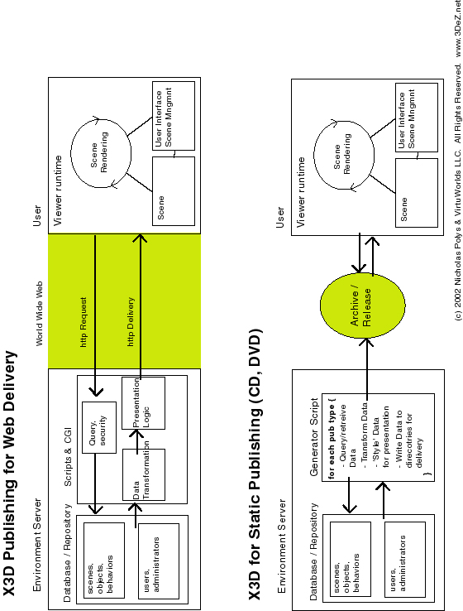

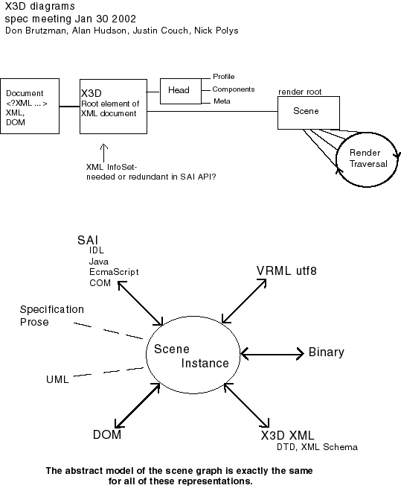
References:

X3D Specification – Milestone 3 draft:
http://www.web3d.org/TaskGroups/x3d/specification-2002february/index.html

VRML97 Specification:
http://www.web3d.org/technicalinfo/specifications/vrml97/index.htm

Web3D Software Development Kit
http://sdk.web3d.org

World Wide Web Consortium:
http://www.w3c.org

Gnome XML libs for Perl:
http://www.xmlsoft.com

NIST X3D-VRML translators:
http://ovrt.nist.gov/translators.html

VRML browser sniffer (from NIST):
http://cic.nist.gov/vrml/vbdetect.html

X3D TaskGroup content & translation examples:
http://www.web3d.org/TaskGroups/x3d/translation/examples

Williams, Clifton: Network Application Server using XML to Support Distributed Databases and 3D Environments, forthcoming Master’s thesis Naval Postgraduate School. http://theses.nps.navy.mil

Apache Software Foundation [Tomcat, Cacoon, etc]:
http://www.apache.org

Walsh, Aaron & Bourges-Sevenier, Mikael: Core Web3D,
Prentice Hall 2001 Upper Saddle River, NJ.
http://www.coreweb3d.com/
http://www.web3dgallery.com

Protos: Web3D Consortium PROTO Repository:
http://sdk.web3d.org/spring2002disk1/content/PROTORepository/root/index.html
By Roland Smeenk: http://www.smeenk.com
By Peter Gerstman: http://www.accad.ohio-state.edu/~pgerstma/protolib/

Web3D Repository:
http://www.web3d.org/vrml/vrml.htm

Deep Matrix Multi-User :
http://www.geometrek.com/products/deepmatrix.html
used with php server-side wrapper: http://www.sound-space.de

Reverend ‘Bob’s VRMLWorks:
http://home.hiwaay.net/~crispen/vrmlworks/

VapourTech – VRML Guide
http://www.vapourtech.com

Joe Williams, Williams Publications:
http://www.hypermultimedia.com

ParallelGraphics VRMLPad:
http://www.parallelgraphics.com/products/vrmlpad

Spazz3D authoring tool:
http://www.spazz3d.com

Chisel post-production tool (now in Consortium Open Source):
http://www.trapezium.com

New & improved 3D S Max VRML exporter:
http://www.edgewise-consulting.com

http://www.3DeZ.net :
The 3DeZine with Feature articles on the Web3D, Resources, and the VirtuPortal entryway to the Industry


